**Practical No. 11**

1. **Working with Screen Orientation, ToggleButton and**

**Switch**

**Designing UI:**

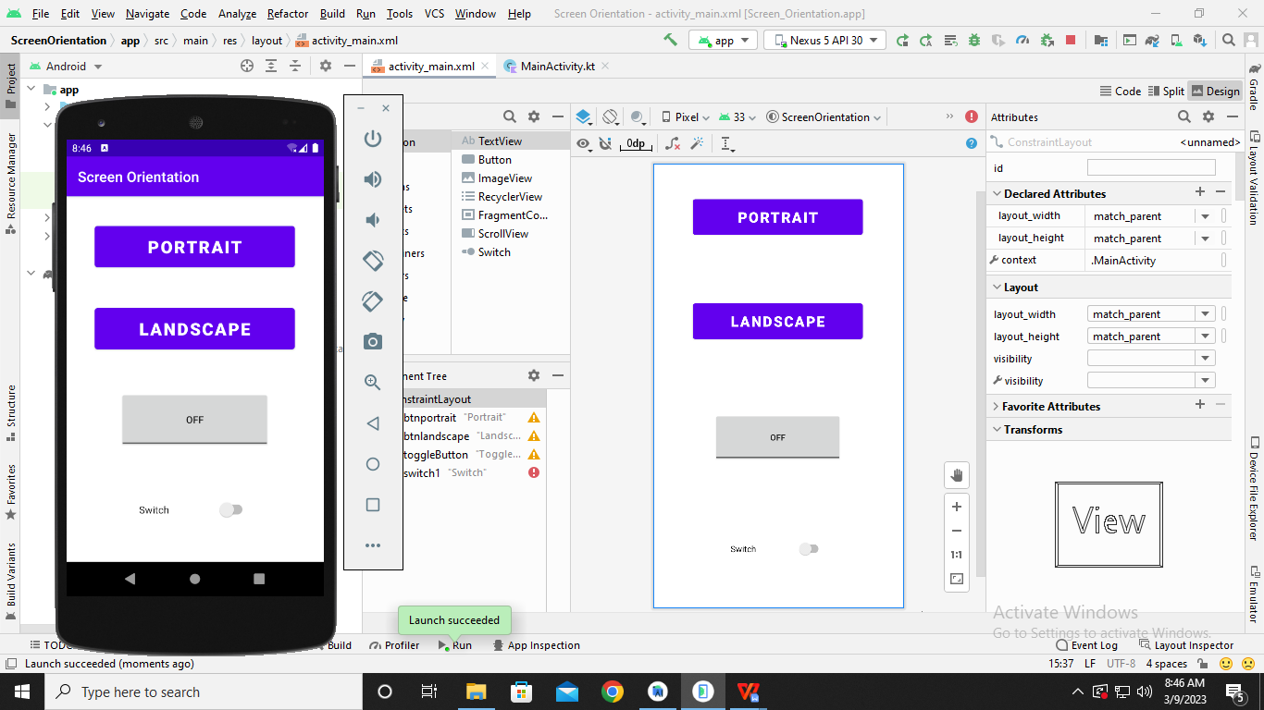

**Code:**

**package** com.example.screenorientation  
  
**import** android.content.pm.ActivityInfo  
**import** androidx.appcompat.app.AppCompatActivity  
**import** android.os.Bundle  
**import** android.view.View  
**import** android.widget.Button  
**import** android.widget.Switch  
**import** android.widget.Toast  
**import** android.widget.ToggleButton  
  
**class** MainActivity : AppCompatActivity() {  
 **override fun** onCreate(savedInstanceState: Bundle?) {  
 **super**.onCreate(savedInstanceState)  
 setContentView(R.layout.*activity_main*)  
  
 **val** portrait = findViewById<View>(R.id.*btnportrait*)**as** Button  
 **val** landscape = findViewById<View>(R.id.*btnlandscape*) **as** Button  
 **val** tb = findViewById<View>(R.id.*toggleButton*) **as** ToggleButton  
 **val** sb = findViewById<View>(R.id.*switch1*) **as** Switch  
  
 sb.setOnClickListener **{  
 if** (sb.*isChecked*) {  
 Toast.makeText(*applicationContext*, **"ON"**, Toast.*LENGTH_LONG*).show()  
 sb.*text* = **"ON"** }  
 **else** {  
 Toast.makeText(*applicationContext*, **"OFF"**, Toast.*LENGTH_LONG*).show()  
 sb.*text* = **"OFF"** }  
 **}** tb.setOnClickListener **{  
 if** (tb.*isChecked*) {  
 Toast.makeText(*applicationContext*, **"Checked true"**, Toast.*LENGTH_LONG*).show()  
 }  
 **else**{  
 Toast.makeText(*applicationContext*, **"Checked false"**, Toast.*LENGTH_LONG*).show()  
 }  
 **}** portrait.setOnClickListener **{  
 this**@MainActivity.*requestedOrientation* = ActivityInfo.*SCREEN_ORIENTATION_PORTRAIT* **}** landscape.setOnClickListener **{  
 this**@MainActivity.*requestedOrientation* = ActivityInfo.*SCREEN_ORIENTATION_LANDSCAPE* **}** }  
}

**Output:**

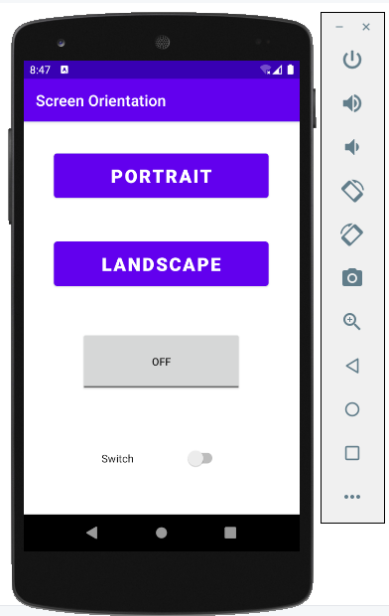

**After Clicking ‘LANDSCAPE’**

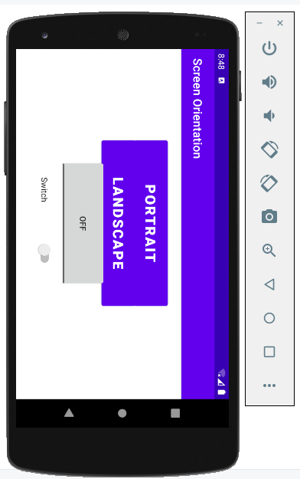

**After Clicking ‘PORTRAIT’**

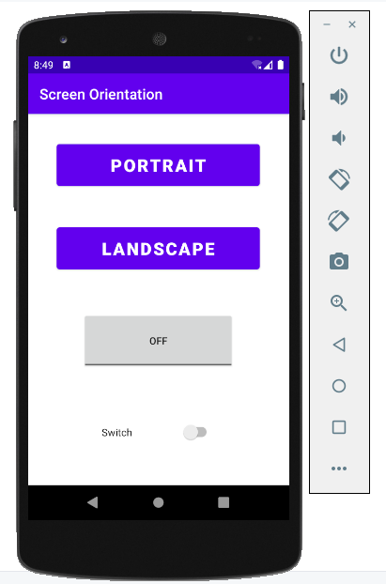

**After Clicking ‘ToggleButton’**

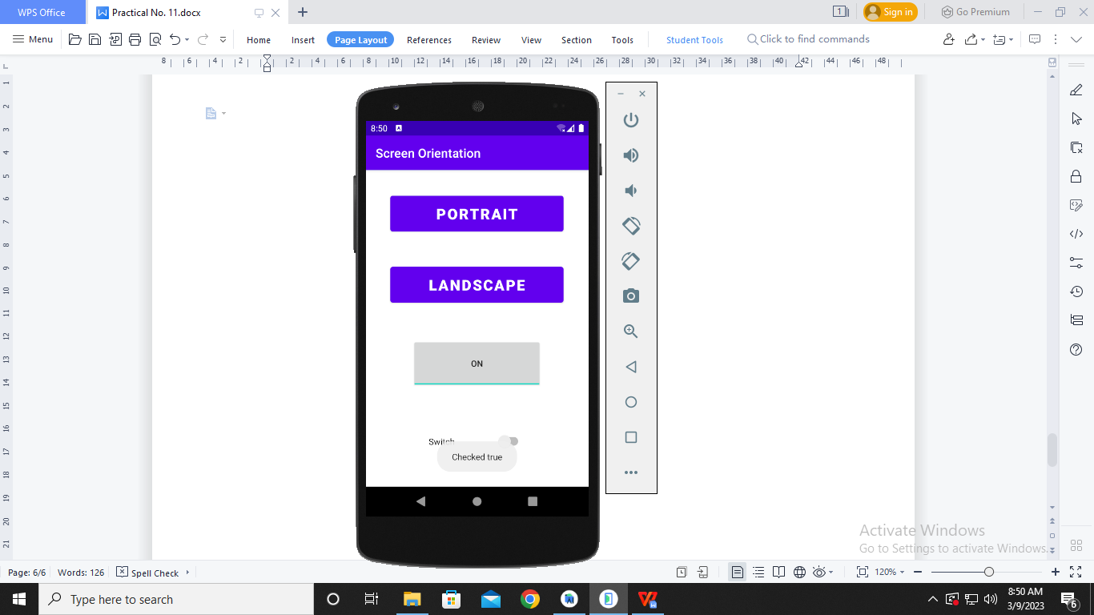

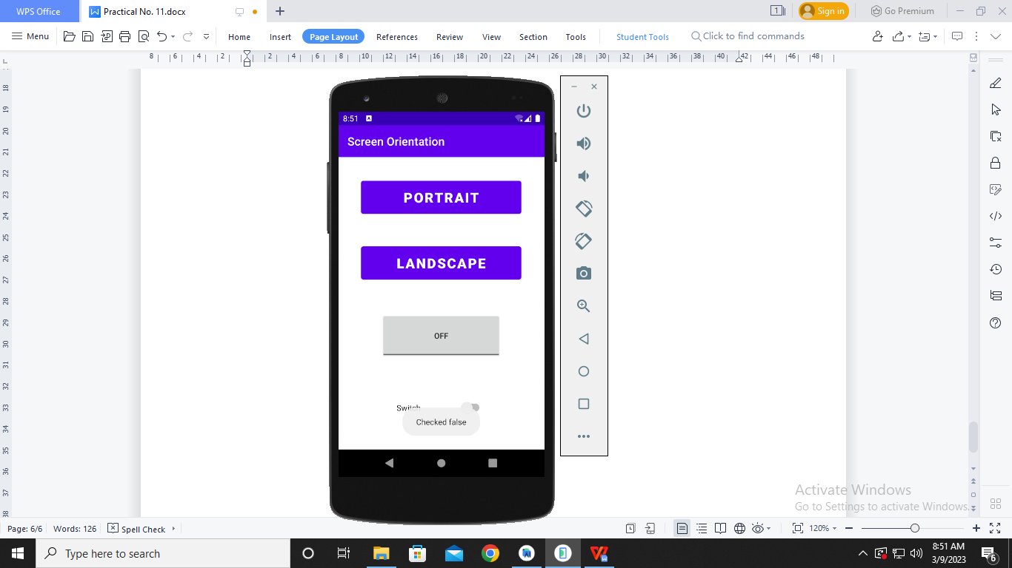

**After clicking ‘Switch’**

